**Schedule Diagram**

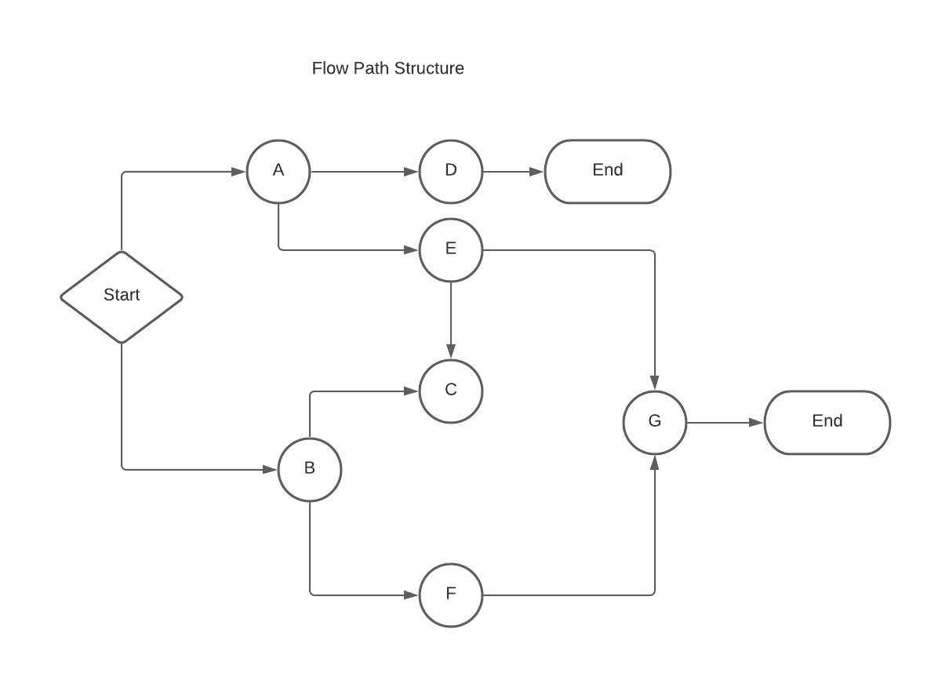

Schedule Structure :

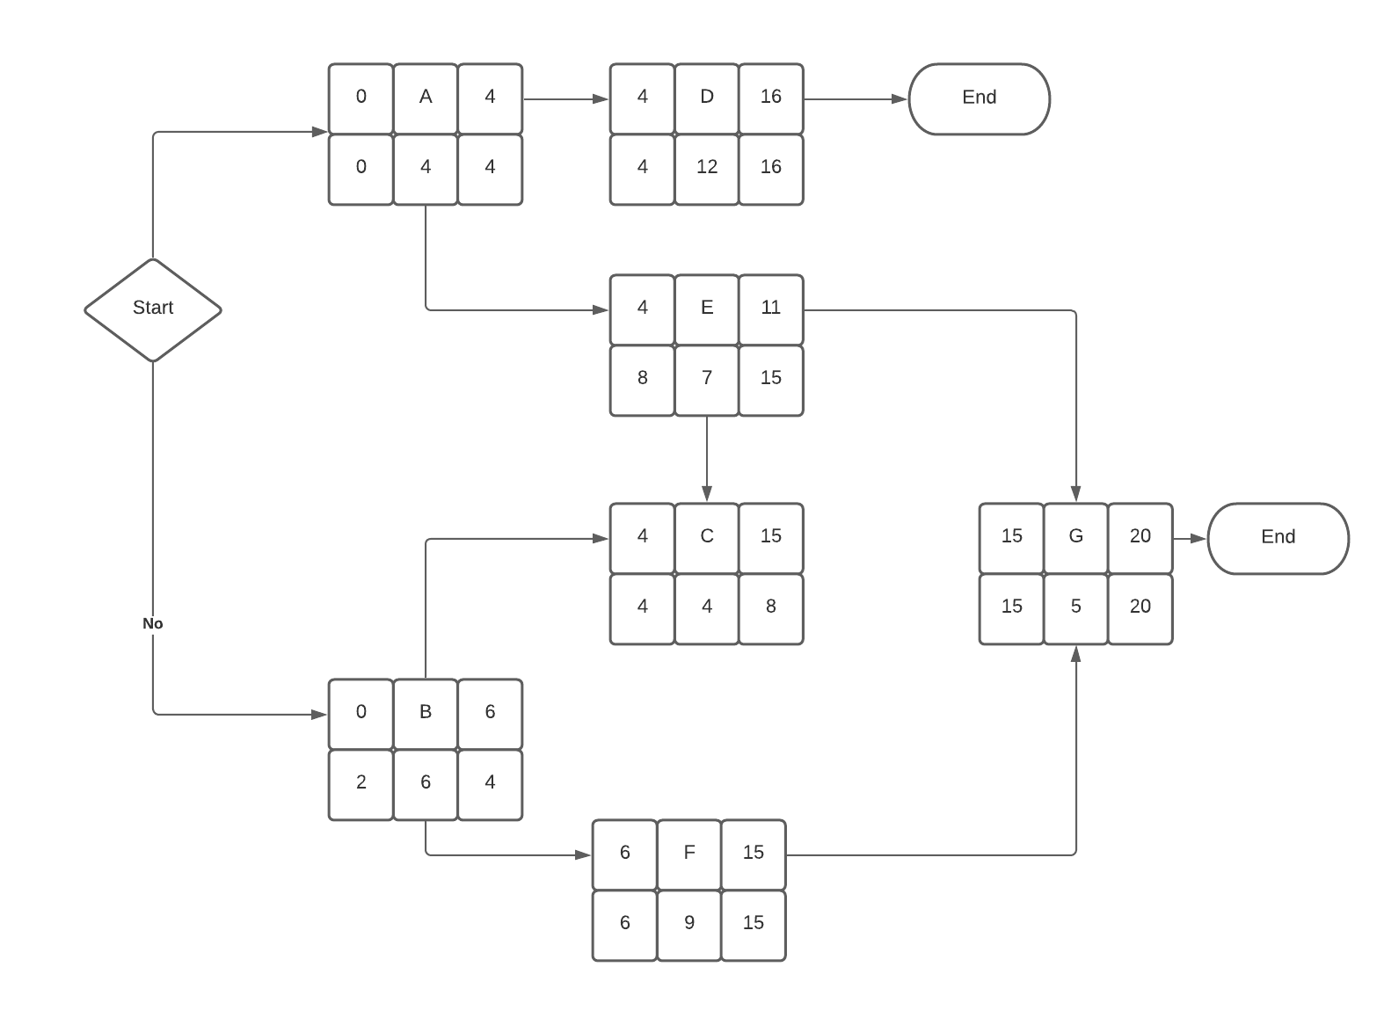

From the above schedule diagram, after calculating the forward and backward pass, the critical path is

Start → A → D

And

Start → B → F → G

Critical path is calculated based on

Early Finish === Lathe Finish